# Create your first Multichain Node

## Prerequisites:

You have enabled Multichain in your Cloud Foundry global account. If not, check the Hands-On document [“Enable Multichain in Canary”](https://jam4.sapjam.com/groups/5yjoVnClxw91MBszN8mO6c/documents/jCV8sBpLPdMMYykrz308re/slide_viewer).

## Preparation:

Log on to your SAP Cloud Foundry Account and navigate to your space (e.g. dev space). You will see your application deployed if any:

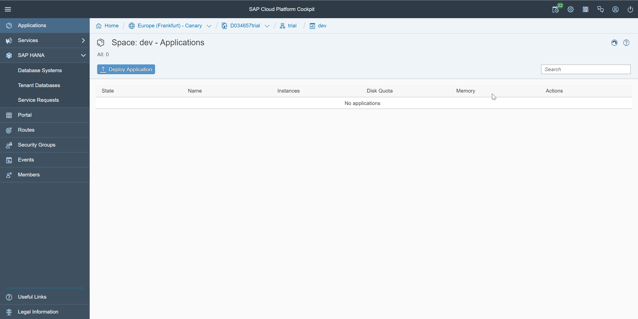

## Create a multichain instance:

Navigate to Services => Service Marketplace.

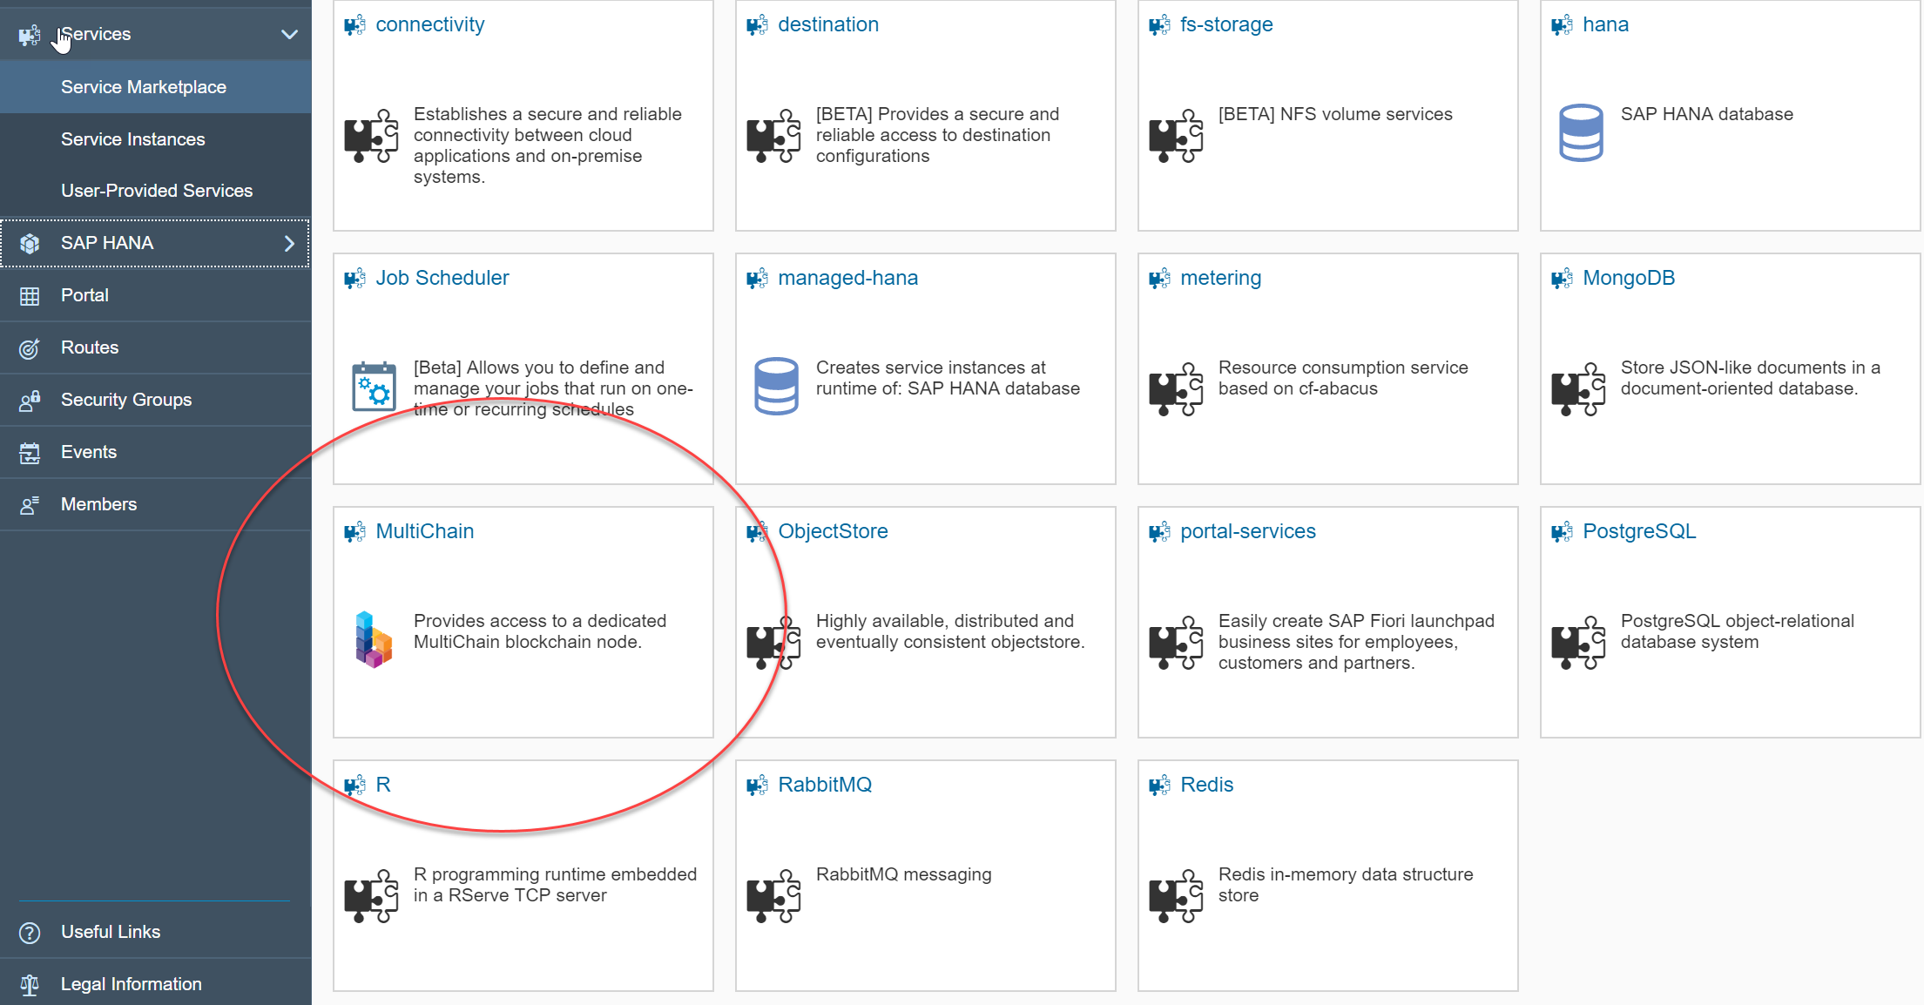

Click on the Multichain tile.

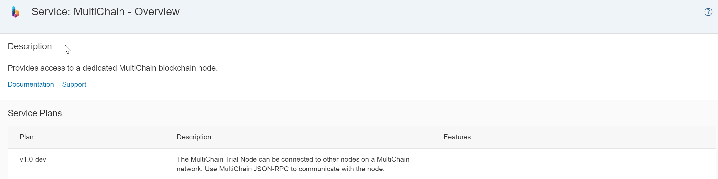

This is the entry page for your Multichain service. We currently offer only one service plan that allows you to setup and monitor a new multichain node, integrate this in a network of multichain nodes and communicate with the node using json-rpc. The service is based on Multichain 1.0 is not intended for productive usage. You may navigate to Documentation and Support to get the latest information.

On the side bar on the left select instances.

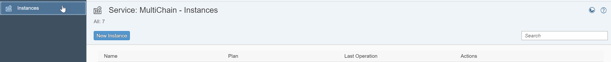

Since you do not have created an instance, the list is empty. Create a new instance by clicking on <New Instance> and you will be guided through the setup process.

In the first step choose the service plan. As we currently have only one, choose it and click next.

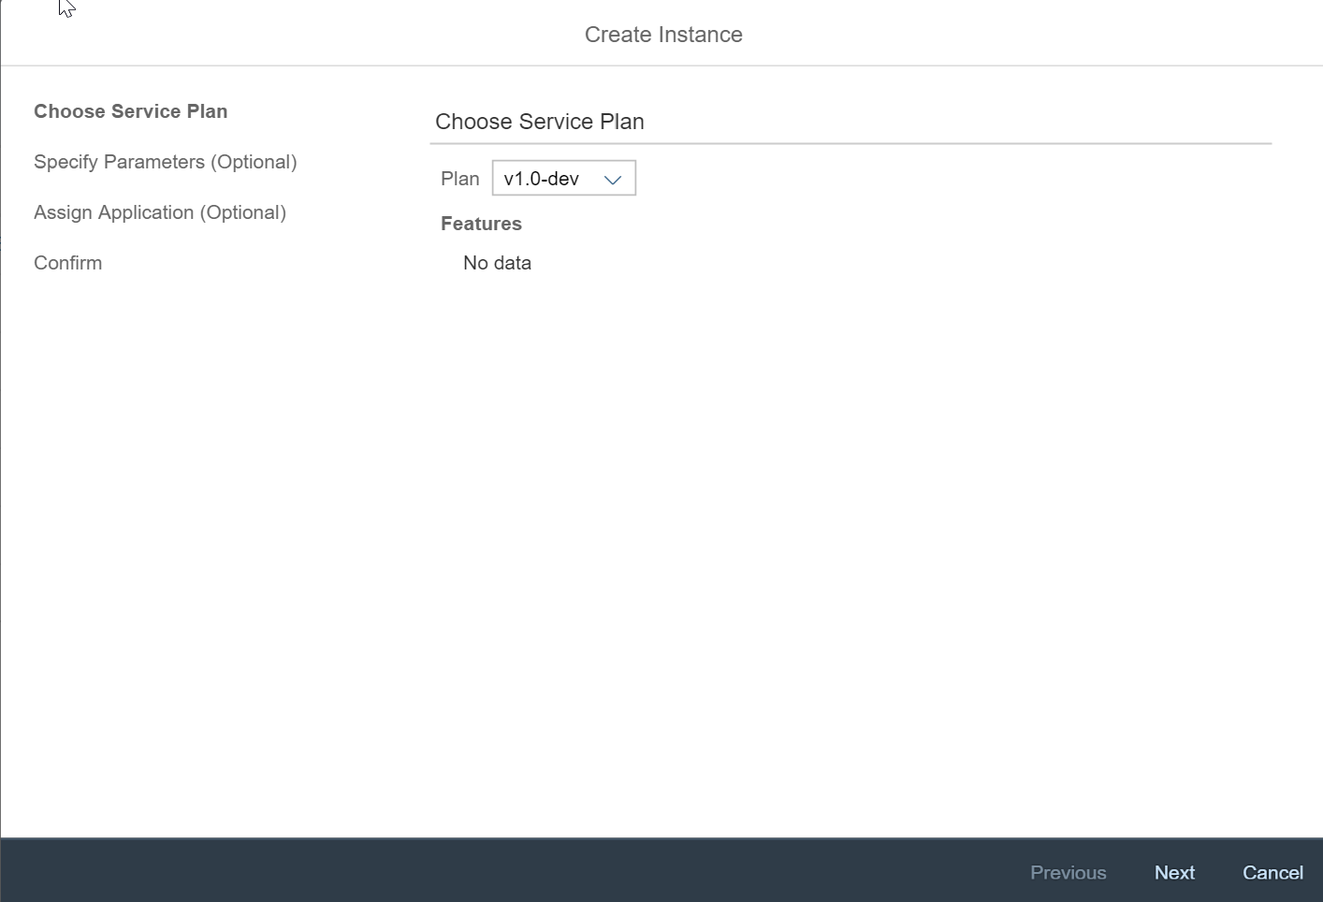

In the next step you can specify any parameters either by uploading a file or enter them in the text box directly. The format is JSON.

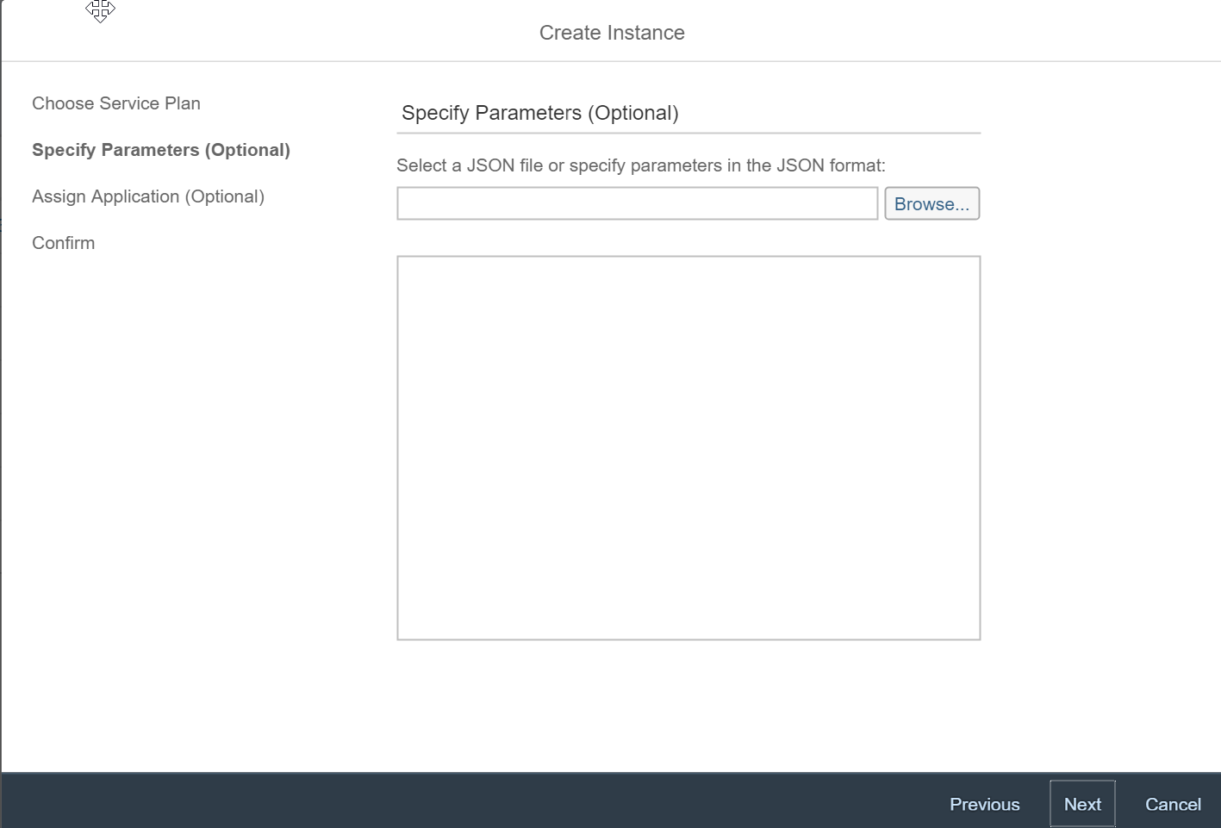

We don’t have any mandatory parameters, so you may directly go to the next step. Optionally, we provide the following parameters:

* chain_name: name of the chain to be created (if empty, a random name is created)
* connect_url: connectURL, if the node should join an existing network in the format <chainName>@<IP address of node to be connected>:<P2P port>. You find this information in the dashboard of the peer node.

For instance, if you want to set the chain name “myChain” for the blockchain of your new node, enter the following json:

{ “chain_name”: “myChain” }

In the next step you can bind a cloud foundry application to your service.

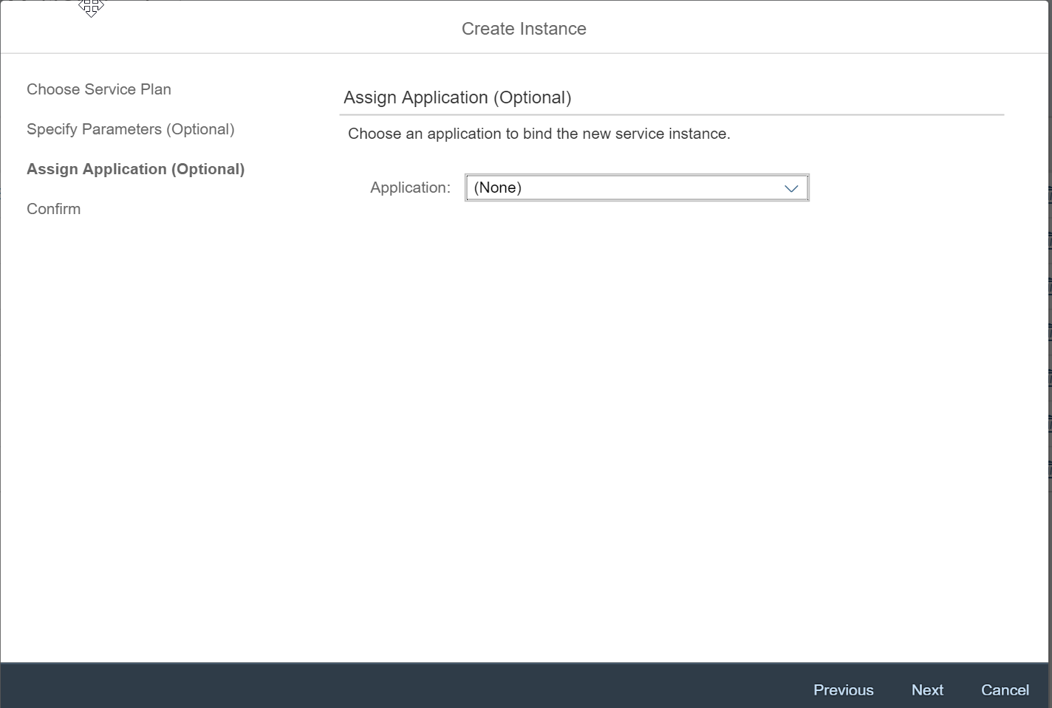

If you only want to play around, you probably don’t want to bind an application now. So, click on next.

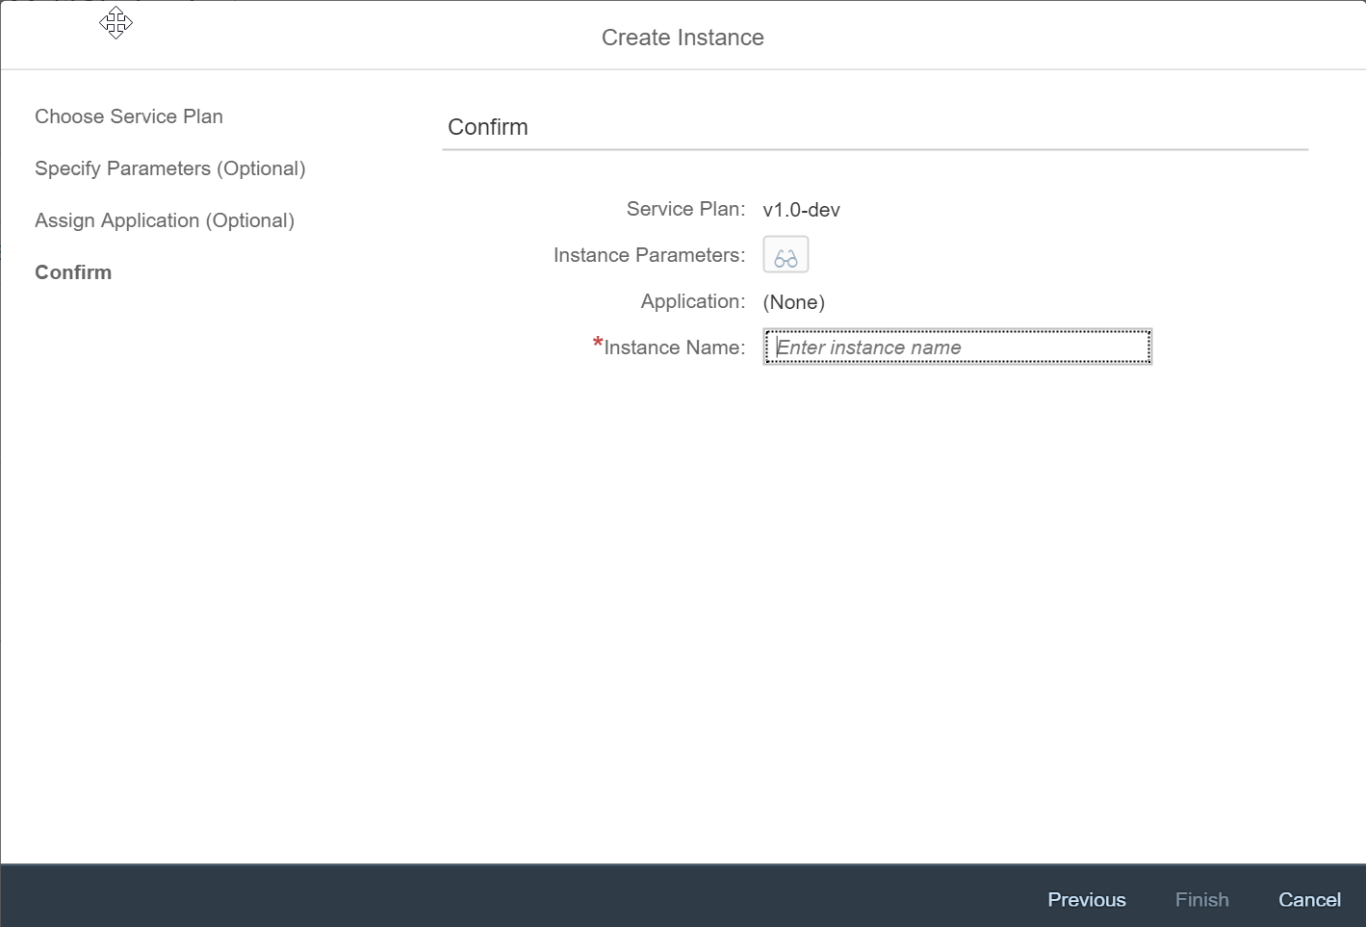

In the last step, you enter a name for your instance. Click on Finish to complete the setup procedure. Your node will be created.



After approximately 30 seconds the new Multichain node is ready.



Your Multichain Node is running, but you have not yet access to it. For this you need to click on your instance and create a service key (“Service Keys” left in the navigation bar). You do not need to provide any configuration parameters since this is not supported/needed for our service.

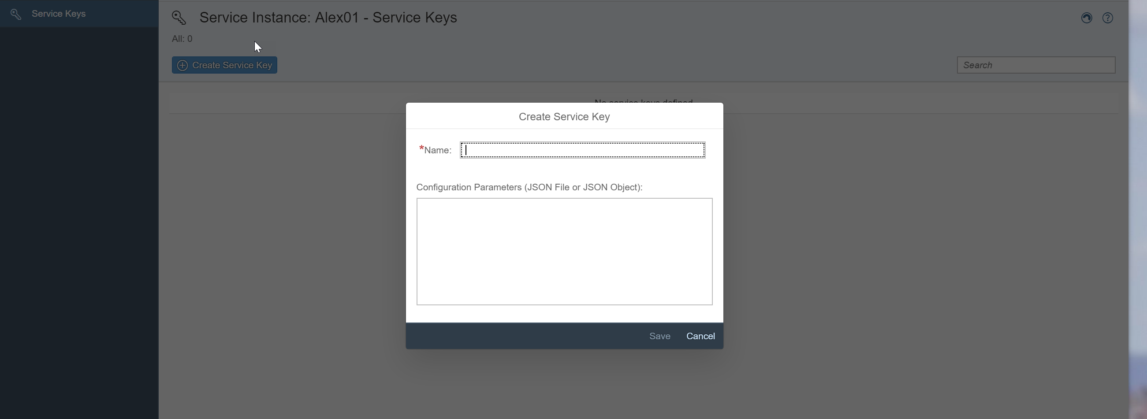

Create a new service key that creates an api key for you to get access to your Multichain Node.

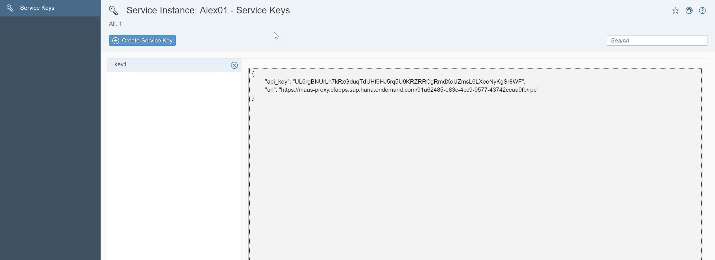

(If you don’t see the json on the right tab, click CTRL-F5 to refresh your instance => this is a known SAP Cloud Foundry bug).

Note down (copy) your service key as you need this key whenever you access the multichain node. With the url parameter you get the url to trigger json-rpc calls to the node.

For instance, get info from the Multichain node by the following command:

POST HTTP/1.1

Host: maas-proxy.cfapps.sap.hana.ondemand.com/91a62485-e83c-4cc9-9577-43742ceaa9fb/rpc

apikey: <your api key>

{ "method": "getinfo", "params":[] }

Mind, that all request are POST requests and you enter your api key as header field. The json-rpc description of Multichain can be found on: <https://www.multichain.com/developers/json-rpc-api/> You will find how to trigger a transaction, create a stream etc., all you need to communicate with your blockchain.

The Multichain also comes with a technical monitoring. Go back to your instance and click on “Open Dashboard”.

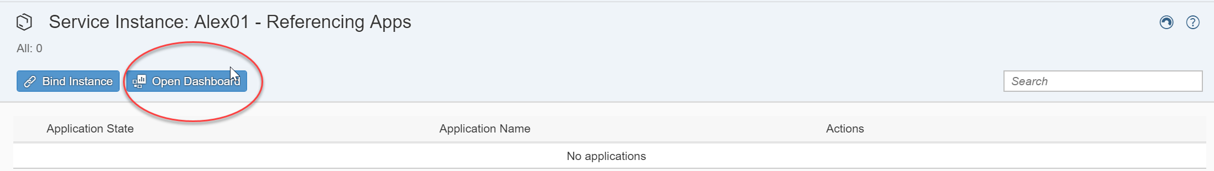

With the Multichain Dashboard you can explore your Multichain instance. For the time-being you have to enter a name (e.g. Explorer) and your api key to authorize.

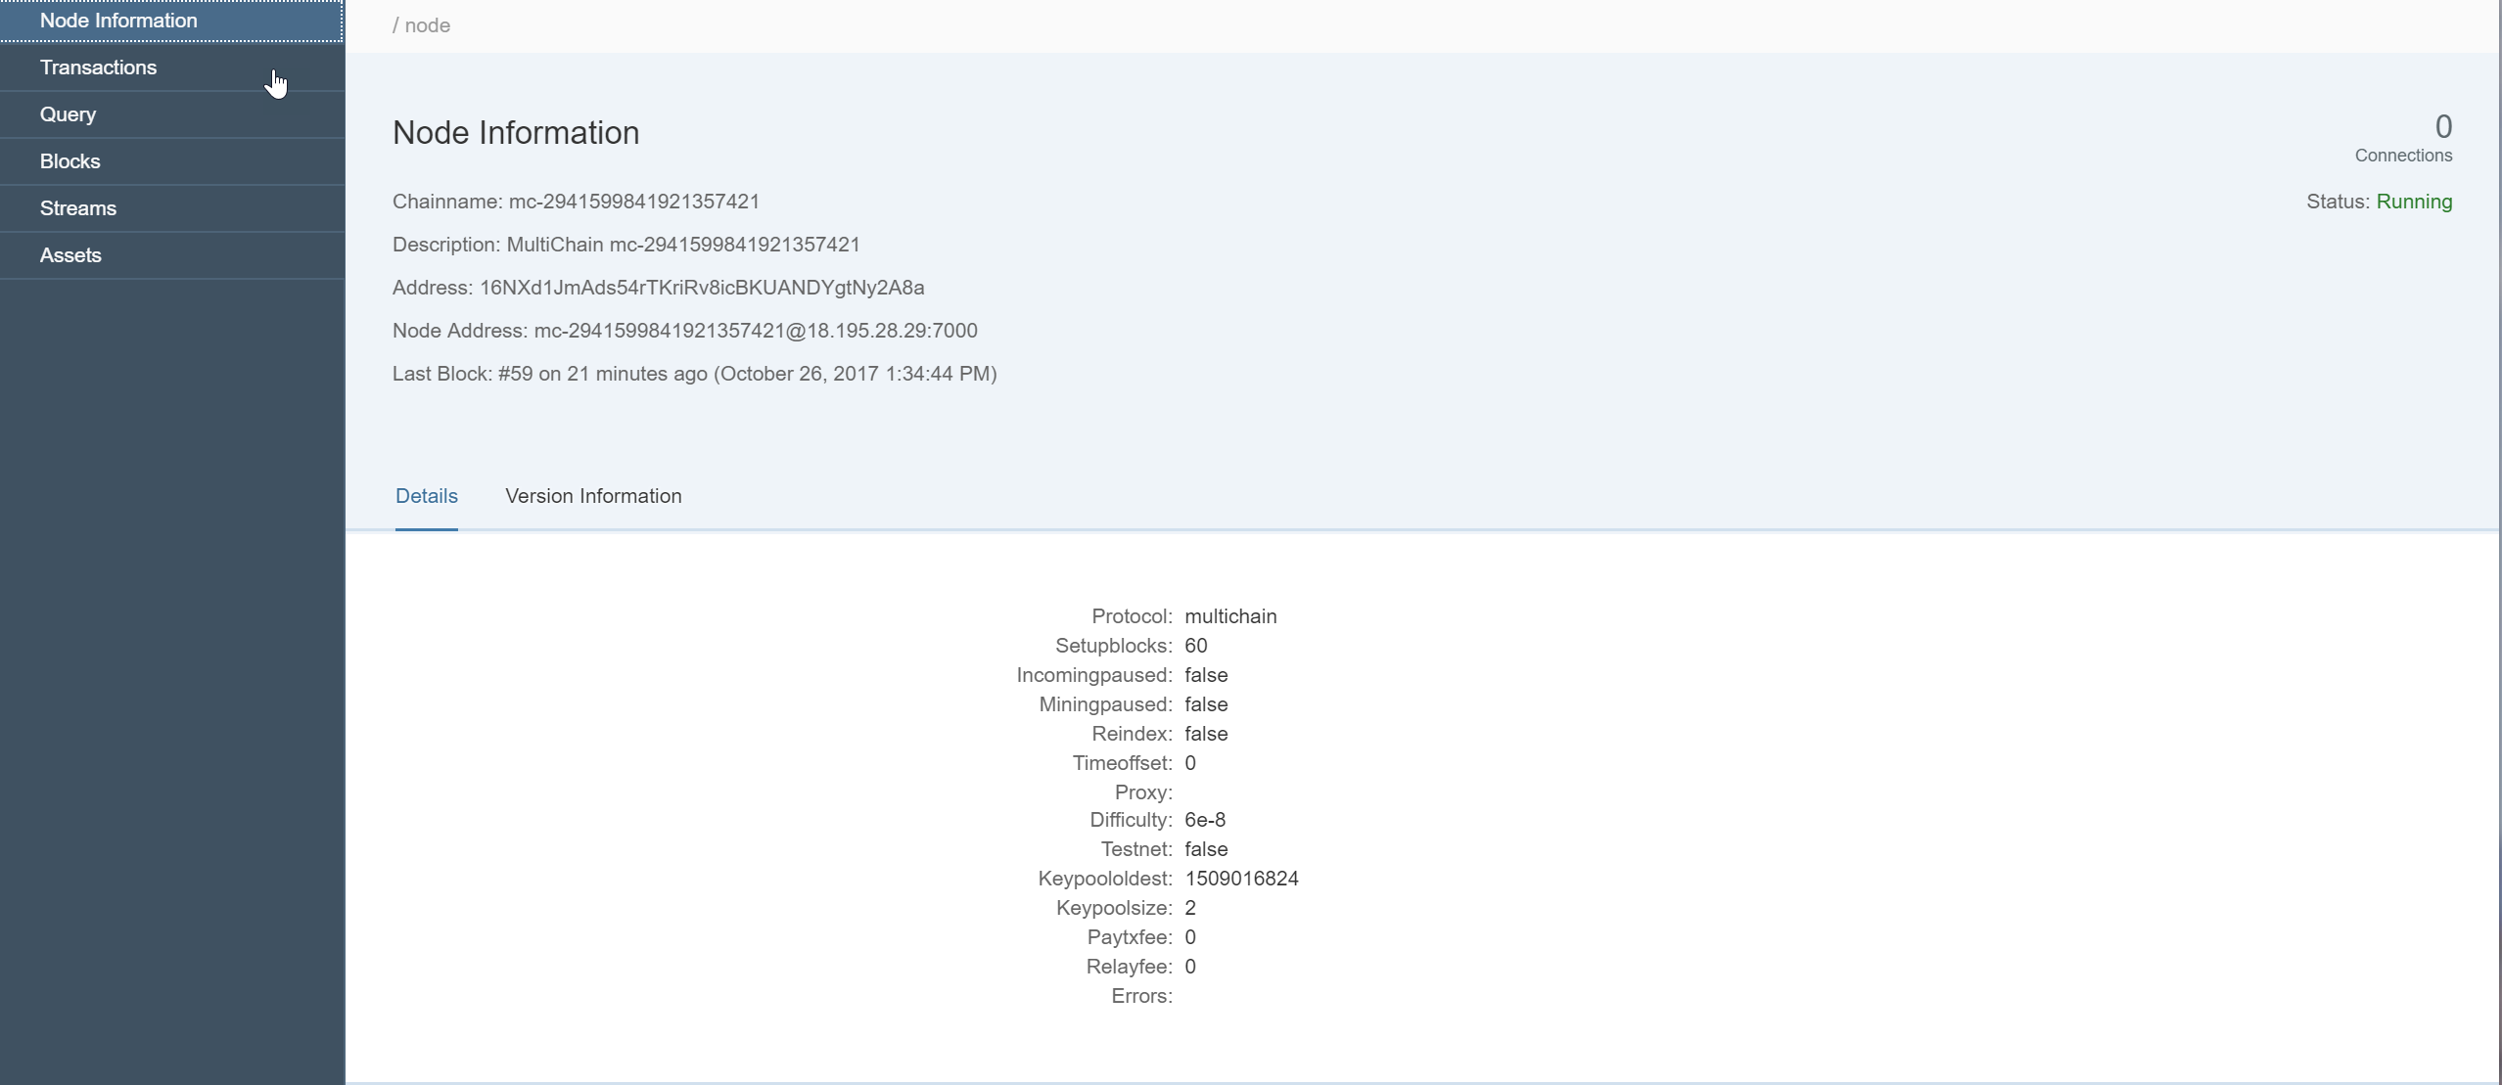

For example, on the upper right you see, that your newly created node is not yet connected to other peers (connections = 0). Proceed to next hands-on session “Build up your own Multichain network”.